**Short course on deterministic radio propagation modeling and ray tracing**

**Final project - January 2013**

**Problem 1)**

Let’s consider the 2.4GHz radio link described here below. An EIRP (PT GT) of 3,14dBW is emitted from the Tx. The link is operating in the environment depicted in the figure.

Diffraction from horizontal edges, diffuse scattering, transmitted and over-roof-top rays can be neglected.

|  |  |  |
| --- | --- | --- |
|  | *Tx* | *Receiver* |
| *Position* | (x=25, y=11, z=2) | (x=9, y=2, z=2) |
| *Antenna* | Vertical /2 Dipole GMAX=2,14dBi | Vertical /2 Dipole GMAX=2,14dBi |

The electromagnetic characteristics of building walls are: εr=5, σ=0.01 [S/m]



Environment topology – top view

Question 1.1) It is requested to compute the total coherent received power and the RMS delay spread at the Rx assuming max one interaction per ray (Nev=1, edge diffraction or reflection only).

Question 1.2) It is requested to give an estimate of fast fading fluctuation depth (approximate number of dB’s).

**SOLUTION OUTLINE**

**Problem 1)**

There are 2 rays, neglecting the horizontal-wedge diffracted one (see figure). Horizontal wedge diffraction can be neglected because the Rx is far from the ISB and RSB boundaries on the Keller’s cone, and therefore the diffraction contribution is certainly very week.

By coherently summing the two contributions at the Rx, the results reported in the following can be obtained:

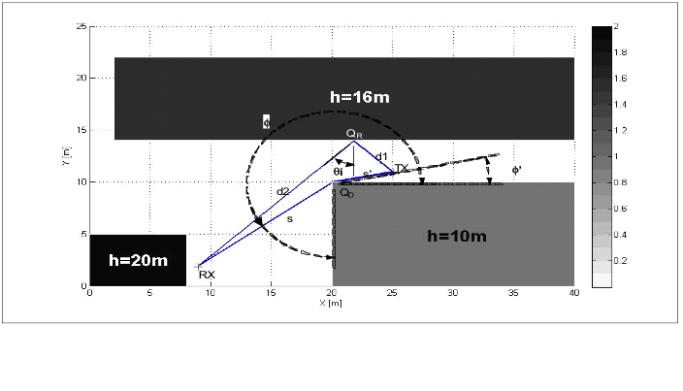

**REFLECTED RAY:**

|  |  |
| --- | --- |
|  |  |
|  | *Reflection Coefficient (TE)* |
|  | *Radiated Field* |
|  |  |
|  | *Reflected Ray Field* |
|  | *Reflected Ray Power contribution* |

**DIFFRACTED RAY:**

|  |  |
| --- | --- |
|  |  |
|  | *Diffraction Coefficient - GTD*  *(conducting edge)* |
|  |  |
|  | *Spreading Factor for Spherical Wave* |
|  | *Incident Field* |
|  | *Diffracted Ray Field* |
|  | *Diffracted Ray Power contrinution* |

**TOTAL RECEIVED POWER:**



**DELAY SPREAD:**

|  |  |
| --- | --- |
|  |  |
|  |  |
|  |  |

**ESTIMATED FADING DEPTH:**

The fading depth can be obtained by simple worst case/best case (counter-phase summing/in-phase summing) considerations on the interference between the two rays. Since there is a power gap of about 20 dB’s between the two contributions, i.e. the diffracted signal is 100 times weaker than the reflected one, fading depth is of only a fraction of dB: less than 0.01 dBs in particular.