**Midterm Exam for《Microwave Engineering and Antenna Design》**

**（Fall Semester 2018）**

**Name: Student ID: Score:**

**Problem 1(25%):** A coaxial line resonator with inner and outer conductors at *a*=5mm and *b*=20mm, and with conducting plates at *z*=0 and *z*=*l*, is filled with a dielectric with =2.56, =1, and =0. The instantaneous magnetic field intensity inside the sourse-free dielectric medium is given by



Find the following:

1. The electric field intensity within the dielectric.
2. The surface current density **J**s at the conductor surfaces at =*a* and**=*b*.
3. The displacement current density **J**d at any point within the dielectric.
4. The total displacement current flowing through the circumferential surface of the resonator.

**Problem 2(25%):** The electric field inside an infinite length rectangular pipe, with all four vertical sides perfectly electric conducting, as shown in Figure 1, is given by



Assuming that there are no sources within the box and *a*=, *b*=*0.5*, and, where =free space, infinite medium wavelength, find the (a) conductivity and (b) dielectric constant of the medium within the box.

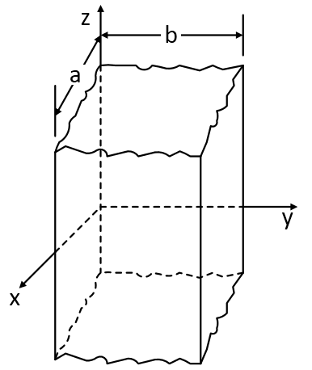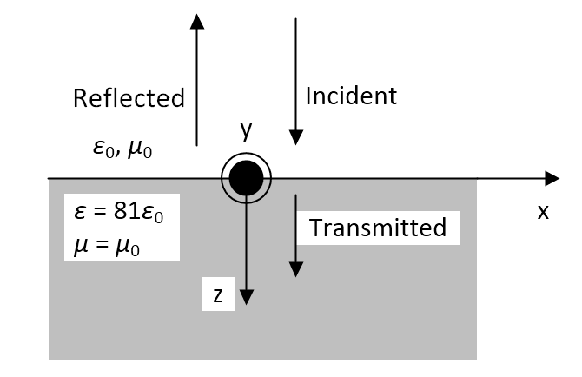

**Figure 1 Figure 2**

**Problem 3(25%):**A time-harmonic electromagnetic field traveling in free space and perpendicularly incident upon a flat surface of distilled water (=81, =), as shown in Figure 2, creates a reflected field on the free-space side of the interface and a transmitted field on the water side of the interface. Assuming the incident (), reflected (), and transmitted () electric fields are given, respectively, by







Determine the coefficients and. *E0* is a constant,, .

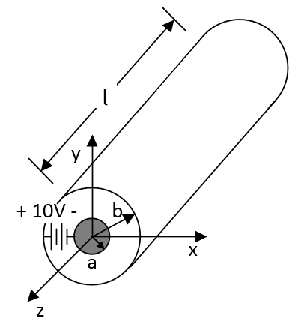

**Figure 3**

**Problem 4(25%):** A 10-V d.c. voltagesource, placed across the inner and outer conductors of a coaxial cylinder as shown in Figure 3, is used to charge the conductors and is then removed. A cylindrical dielectric jacket of polystyrene (=2.56) of inner radius *a*=2 cm and outer radius *b*=3 cm is inserted over the inner conductor of the coaxial cylinder whose length is Ɩ=6 cm. After the insertion of the jacket and neglecting fringing, find

1. The total charge *Q* on the inner and outer conductors.
2. The surface charge density on the inner and outer conductors.
3. The electric flux density between the conductors in the dielectric and free space.
4. The electric field intensity between the conductors in the dielectric and free space.
5. The voltage between the conductors.
6. The total capacitance between the conductors.
7. The total energy stored between the conductors.